SOFTWARE TESTING – TEST REPORT
Practical 14: Selenium Web Automation of Automation Exercise
1. Test Report Information
Project Name | Selenium Web Automation
Practical | Practical 14 – Tutorial 14
Application Under Test | Automation Exercise (https://www.automationexercise.com/)
Module Tested | Navigation, Product Selection, Cart and Login Form
Test Type | Automated functional and validation testing (black box)
Automation Script | P14.py
Executed By | PRAJEET PRAJAPAT
Execution Date | 27-10-2026 (started 18:56:57)
Overall Result | PASS (12 of 12 test cases passed)
2. Aim
To create Selenium automation scripts in Python for browser navigation, form handling, web element interaction and validation testing.
3. Application Under Test
Automation Exercise is a public demo e-commerce website. It has a home page, a Products page with a search form, product details pages, a cart opened through a pop-up or the Cart menu link, and a Signup / Login page. The tests ran as a guest user; no account was created and no order was placed.
4. Test Environment
Parameter | Details
Programming Language | Python 3.14.3
Automation Tool | Selenium WebDriver 4.49.0
Browser | Google Chrome 154.0.8037.93
WebDriver | Selenium-managed Chrome WebDriver
IDE | PyCharm
Target URL | https://www.automationexercise.com/
Test Data | Search text: Top  Products: Blue Top (Rs. 500), Men Tshirt (Rs. 400), Sleeveless Dress (Rs. 1000, quantity 3)  Invalid login: invalid.user@example.com / wrongpass123
5. Automation Scenarios
Scenario | Coverage | Test IDs
Browser navigation | Home, Products, Product Details and Cart pages; back/forward; menu links | TC-14-01, 02, 04, 11, 12
Form handling | Product search form; login form with invalid credentials | TC-14-03, 10
Web element interaction | Add to cart, cart pop-up buttons, quantity field, remove link | TC-14-05, 06, 08, 09
Validation testing | URL, page title, messages, cart contents, prices and total | TC-14-02, 04, 07, 08, 10
6. Test Case Execution
Results below are taken from the actual console output of P14.py.
Test ID | Scenario | Expected Result | Actual Result | Status
TC-14-01 | Open website and verify title / URL | Home page opens with title "Automation Exercise" | Title = 'Automation Exercise', URL = https://www.automationexercise.com/ | PASS
TC-14-02 | Navigate to Products page | Products page opens; heading "All Products"; products listed | URL = https://www.automationexercise.com/products, title = 'Automation Exercise - All Products', heading = 'ALL PRODUCTS', 34 products listed | PASS
TC-14-03 | Search form: search for a product | Search results shown | Searched for 'Top': heading = 'SEARCHED PRODUCTS', 14 results | PASS
TC-14-04 | Open product details page | Details of Blue Top (Rs. 500) shown | URL = https://www.automationexercise.com/product_details/1, title = 'Automation Exercise - Product Details', product = 'Blue Top', price = Rs. 500 | PASS
TC-14-05 | Add product to cart (Continue Shopping) | Pop-up "Added!" shown; pop-up closes | 'Blue Top' added, modal title = 'Added!', Continue Shopping closed the modal | PASS
TC-14-06 | Add second product and open cart (View Cart) | Product added; cart page opens | 'Men Tshirt' added, modal title = 'Added!', View Cart opened https://www.automationexercise.com/view_cart | PASS
TC-14-07 | Validate cart contents (names, prices) | Cart has 2 items with correct names and prices | title = 'Automation Exercise - Checkout', 2 items in cart: Blue Top (Rs. 500), Men Tshirt (Rs. 400) | PASS
TC-14-08 | Set quantity and validate cart total | Quantity 3; total = Rs. 1000 x 3 | 'Sleeveless Dress' quantity = 3, price Rs. 1000 x 3 = Rs. 3000 | PASS
TC-14-09 | Remove product from cart | Product removed; 2 items remain | 'Sleeveless Dress' removed, 2 items remain in cart | PASS
TC-14-10 | Login form: invalid credentials error | Error message shown; user stays on login page | title = 'Automation Exercise - Signup / Login', error shown: 'Your email or password is incorrect!' | PASS
TC-14-11 | Browser back / forward navigation | back() opens Home; forward() opens Products | Home -> Products, back() -> Home, forward() -> Products | PASS
TC-14-12 | Cart link and cart persistence | Cart still has 2 items after navigation | Cart link opened https://www.automationexercise.com/view_cart; 2 items still in cart after navigation | PASS
7. Execution Summary
Metric | Value
Automation Scripts Executed | 1
Total Test Cases Executed | 12
Passed | 12
Failed | 0
Pass Percentage | 100%
Execution Time | 118.07 seconds
Overall Status | PASS
8. Observations
Sr. No. | Observation
1 | All 12 test cases passed and no defects were found in the tested scenarios.
2 | Page titles followed the pattern "Automation Exercise - <page name>", and the heading texts appeared in capital letters on screen (for example "ALL PRODUCTS"), so text checks were written to ignore letter case.
3 | The Products page listed 34 products, and searching for "Top" returned 14 results.
4 | The cart pop-up showed "Added!" and both its buttons (Continue Shopping and View Cart) worked.
5 | The quantity field accepted 3, and the cart total Rs. 3000 matched Rs. 1000 x 3. Removing a product updated the cart immediately.
6 | An invalid login was rejected with "Your email or password is incorrect!", and the user stayed on the login page.
7 | Back/forward navigation and the cart link worked, and the cart kept its 2 items across pages.
8 | The script includes a fallback for clicks blocked by a page overlay (remove the overlay and retry). It was not needed in this run, because the console output shows no fallback message.
9 | Only invalid-login behaviour was tested. No registered account was used and no account was created on the public site, so a valid login is outside the scope of this report.
9. Evidence
Insert the screenshots below before submission.
Figure 2: Home page opened by Selenium
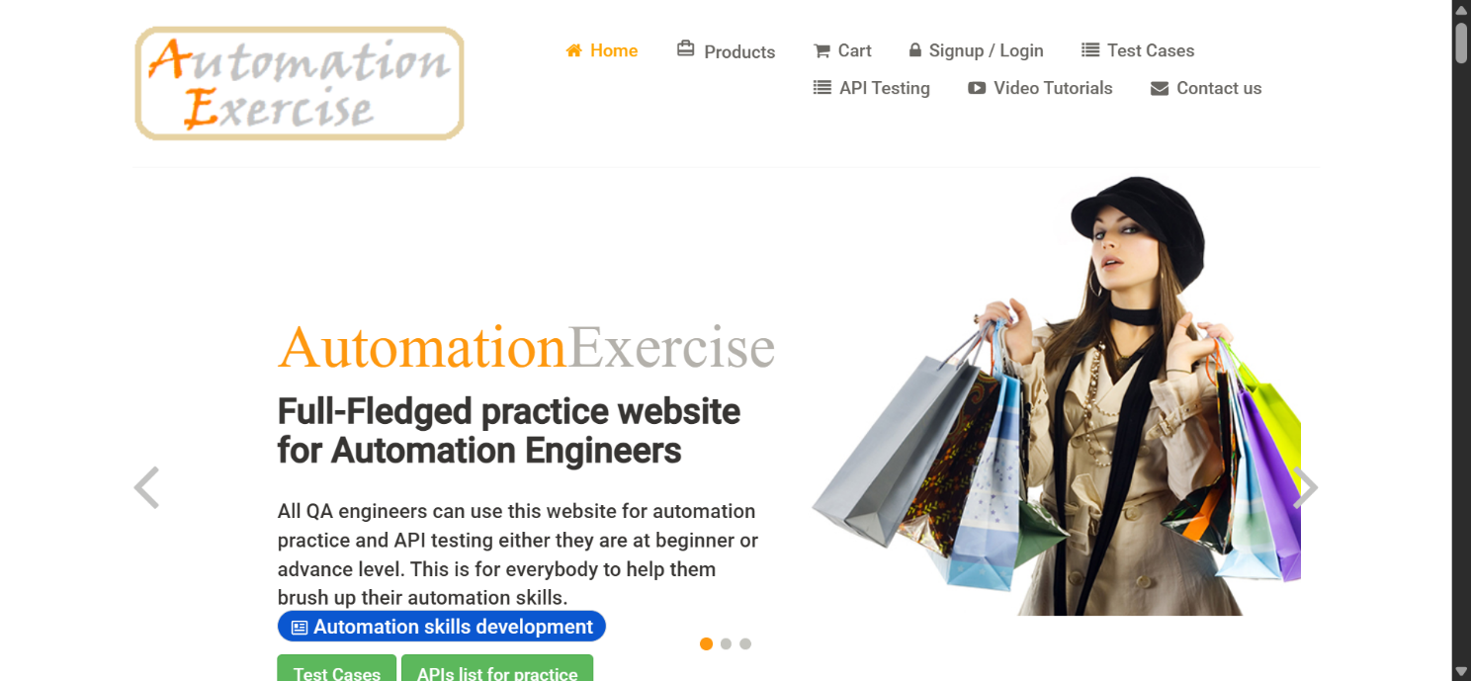
Figure 3: Products page / search results
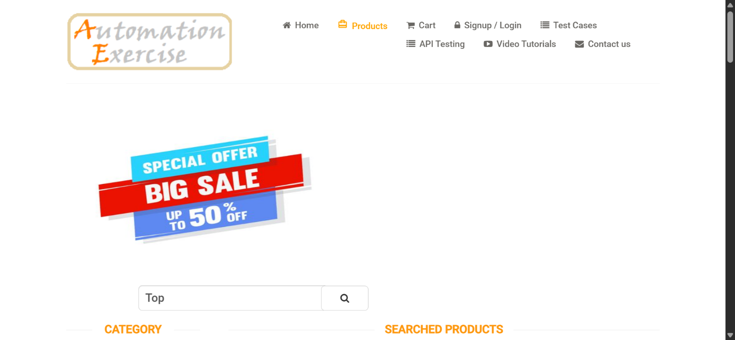
Figure 4: Product added (cart pop-up "Added!")
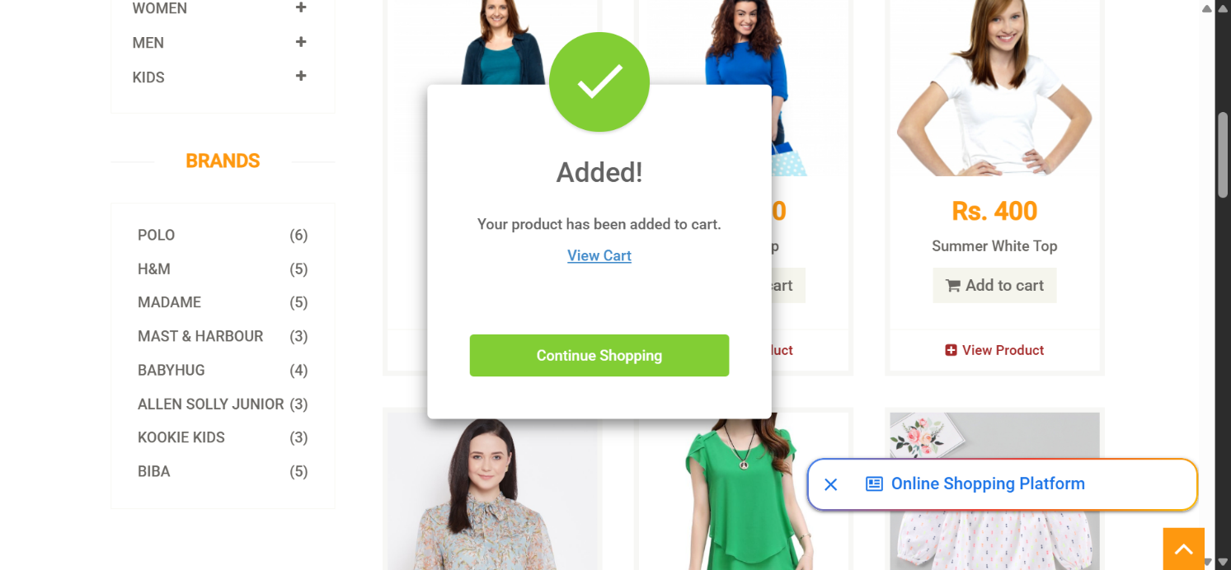
Figure 5: Cart page
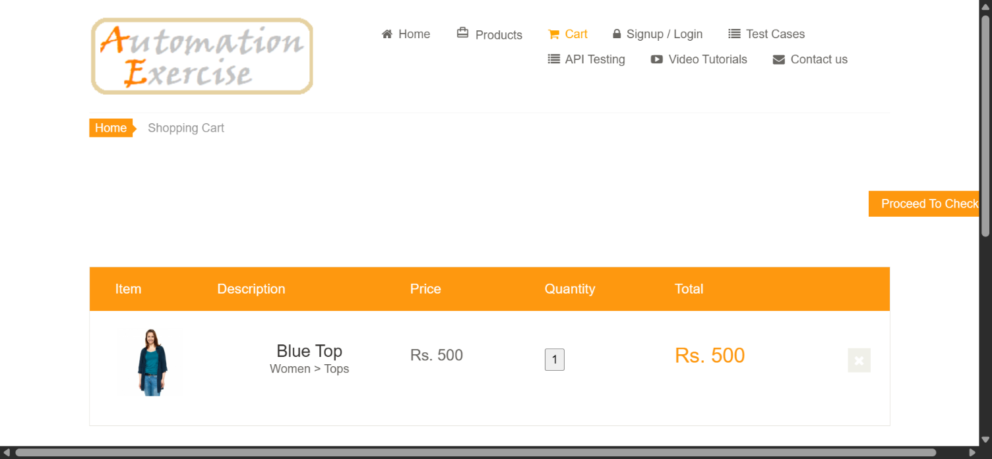
Figure 6: Login page with error message
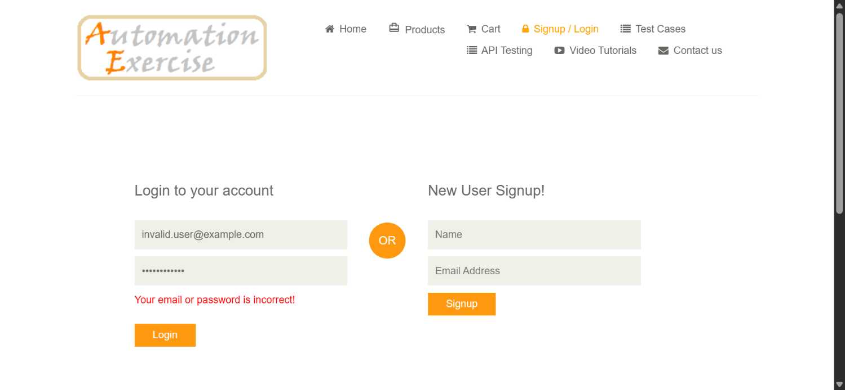
Appendix A: Console Output
======================================================================
Practical 14 - Selenium Web Automation (Automation Exercise)
Execution started: 02-10-2026 18:56:57
======================================================================
Browser : chrome 154.0.8037.93
Selenium: 4.49.0
Python : 3.14.3
URL : https://www.automationexercise.com/

--- TC-14-01: Open website and verify title / URL ---
Result : PASS
Detail : Title = 'Automation Exercise', URL = https://www.automationexercise.com/

--- TC-14-02: Navigate to Products page ---
Result : PASS
Detail : URL = https://www.automationexercise.com/products, title = 'Automation Exercise - All Products', heading = 'ALL PRODUCTS', 34 products listed

--- TC-14-03: Search form: search for a product ---
Result : PASS
Detail : Searched for 'Top': heading = 'SEARCHED PRODUCTS', 14 results

--- TC-14-04: Open product details page ---
Result : PASS
Detail : URL = https://www.automationexercise.com/product_details/1, title = 'Automation Exercise - Product Details', product = 'Blue Top', price = Rs. 500

--- TC-14-05: Add product to cart (Continue Shopping) ---
Result : PASS
Detail : 'Blue Top' added, modal title = 'Added!', Continue Shopping closed the modal

--- TC-14-06: Add second product and open cart (View Cart) ---
Result : PASS
Detail : 'Men Tshirt' added, modal title = 'Added!', View Cart opened https://www.automationexercise.com/view_cart

--- TC-14-07: Validate cart contents (names, prices) ---
Result : PASS
Detail : title = 'Automation Exercise - Checkout', 2 items in cart: Blue Top (Rs. 500), Men Tshirt (Rs. 400)

--- TC-14-08: Set quantity and validate cart total ---
Result : PASS
Detail : 'Sleeveless Dress' quantity = 3, price Rs. 1000 x 3 = Rs. 3000

--- TC-14-09: Remove product from cart ---
Result : PASS
Detail : 'Sleeveless Dress' removed, 2 items remain in cart

--- TC-14-10: Login form: invalid credentials error ---
Result : PASS
Detail : title = 'Automation Exercise - Signup / Login', error shown: 'Your email or password is incorrect!'

--- TC-14-11: Browser back / forward navigation ---
Result : PASS
Detail : Home -> Products, back() -> Home, forward() -> Products

--- TC-14-12: Cart link and cart persistence ---
Result : PASS
Detail : Cart link opened https://www.automationexercise.com/view_cart; 2 items still in cart after navigation

======================================================================
EXECUTION SUMMARY
======================================================================
TC-14-01 Open website and verify title / URL PASS
TC-14-02 Navigate to Products page PASS
TC-14-03 Search form: search for a product PASS
TC-14-04 Open product details page PASS
TC-14-05 Add product to cart (Continue Shopping) PASS
TC-14-06 Add second product and open cart (View Cart) PASS
TC-14-07 Validate cart contents (names, prices) PASS
TC-14-08 Set quantity and validate cart total PASS
TC-14-09 Remove product from cart PASS
TC-14-10 Login form: invalid credentials error PASS
TC-14-11 Browser back / forward navigation PASS
TC-14-12 Cart link and cart persistence PASS
----------------------------------------------------------------------
Total test cases executed : 12
Passed : 12
Failed : 0
Execution time : 118.07 seconds
Overall status : PASS
======================================================================
Appendix B: Source Code (P14.py)
"""
Practical 14 - Selenium Web Automation (Software Testing)
Application Under Test : Automation Exercise (https://www.automationexercise.com/)
Tool / Language : Selenium WebDriver + Python (Google Chrome, PyCharm)

Covers: browser navigation, form handling (search form and login form), web
element interaction (links, buttons, quantity field, modal dialog), product
selection, add to cart, cart validation and URL / page title validation.

The tests run as a guest user. No account is created and no order is placed.
If a test fails, a screenshot "PR14_FAIL_<test id>.png" is saved in the
folder from which the script is run.

Install : pip install selenium
Run : python PR14.py
"""

import sys
import time
from datetime import datetime

import selenium
from selenium import webdriver
from selenium.common.exceptions import (
ElementClickInterceptedException,
NoSuchElementException,
TimeoutException,
WebDriverException,
)
from selenium.webdriver.common.by import By
from selenium.webdriver.support import expected_conditions as EC
from selenium.webdriver.support.ui import WebDriverWait

# --------------------------------------------------------------------------
# Test data
# --------------------------------------------------------------------------
BASE_URL = "https://www.automationexercise.com"
SEARCH_TEXT = "Top"
INVALID_EMAIL = "invalid.user@example.com"
INVALID_PASSWORD = "wrongpass123"

# product id -> (name, price)
PRODUCTS = {
1: ("Blue Top", "Rs. 500"),
2: ("Men Tshirt", "Rs. 400"),
3: ("Sleeveless Dress", "Rs. 1000"),
}
QUANTITY = 3

# --------------------------------------------------------------------------
# Locators
# --------------------------------------------------------------------------
NAV_HOME = (By.CSS_SELECTOR, ".shop-menu a[href='/']")
NAV_PRODUCTS = (By.CSS_SELECTOR, ".shop-menu a[href='/products']")
NAV_CART = (By.CSS_SELECTOR, ".shop-menu a[href='/view_cart']")
NAV_LOGIN = (By.CSS_SELECTOR, ".shop-menu a[href='/login']")

PAGE_HEADING = (By.CSS_SELECTOR, ".features_items h2.title")
PRODUCT_CARDS = (By.CSS_SELECTOR, ".features_items .product-image-wrapper")
SEARCH_BOX = (By.ID, "search_product")
SEARCH_BTN = (By.ID, "submit_search")

DETAIL_NAME = (By.CSS_SELECTOR, ".product-information h2")
DETAIL_INFO = (By.CSS_SELECTOR, ".product-information")
QUANTITY_FIELD = (By.ID, "quantity")
DETAIL_ADD_BTN = (By.CSS_SELECTOR, "button.cart")

CART_MODAL = (By.ID, "cartModal")
CART_MODAL_TITLE = (By.CSS_SELECTOR, "#cartModal .modal-title")
CART_MODAL_CONTINUE = (By.CSS_SELECTOR, "#cartModal button.close-modal")
CART_MODAL_VIEW_CART = (By.CSS_SELECTOR, "#cartModal a[href='/view_cart']")
CART_ROWS = (By.CSS_SELECTOR, "#cart_info_table tbody tr")

LOGIN_HEADING = (By.CSS_SELECTOR, ".login-form h2")
LOGIN_EMAIL = (By.CSS_SELECTOR, "input[data-qa='login-email']")
LOGIN_PASSWORD = (By.CSS_SELECTOR, "input[data-qa='login-password']")
LOGIN_BTN = (By.CSS_SELECTOR, "button[data-qa='login-button']")
LOGIN_ERROR = (By.CSS_SELECTOR, ".login-form p")

def add_button(pid):
return (By.CSS_SELECTOR, f".productinfo a.add-to-cart[data-product-id='{pid}']")

def view_product_link(pid):
return (By.CSS_SELECTOR, f"a[href='/product_details/{pid}']")

def cart_row(pid):
return (By.ID, f"product-{pid}")

def delete_link(pid):
return (By.CSS_SELECTOR, f"a.cart_quantity_delete[data-product-id='{pid}']")

# --------------------------------------------------------------------------
# Shared state and result tracking
# --------------------------------------------------------------------------
ctx = {"driver": None, "wait": None}
results = [] # (test_id, scenario, status, detail)

def run_test(test_id, scenario, func):
"""Execute one test, handle exceptions, print and record the outcome."""
print(f"\n--- {test_id}: {scenario} ---")
try:
detail = func()
status = "PASS"
except AssertionError as err:
status, detail = "FAIL", f"Assertion failed: {err}"
except TimeoutException:
status, detail = "FAIL", "TimeoutException: expected element/condition not found in time"
except NoSuchElementException as err:
status, detail = "FAIL", f"NoSuchElementException: {err.msg}"
except WebDriverException as err:
status, detail = "FAIL", f"WebDriverException: {str(err).splitlines()[0]}"

if status == "FAIL":
try:
ctx["driver"].save_screenshot(f"PR14_FAIL_{test_id}.png")
detail += f" (screenshot saved: PR14_FAIL_{test_id}.png)"
except Exception:
pass

results.append((test_id, scenario, status, detail))
print(f"Result : {status}")
print(f"Detail : {detail}")
return status == "PASS"

# --------------------------------------------------------------------------
# Helper functions
# --------------------------------------------------------------------------
def d():
return ctx["driver"]

def w():
return ctx["wait"]

def same_url(url, expected):
"""Compare URLs ignoring any #fragment (ads can append #google_vignette) and trailing slash."""
return url.split("#")[0].rstrip("/") == expected.rstrip("/")

def has_text(actual, expected):
return expected.lower() in actual.lower()

def remove_ad_overlays():
"""Remove third-party advertisement elements that can cover the page and block clicks."""
d().execute_script("""
document.querySelectorAll(
"ins.adsbygoogle, iframe[id^='aswift'], iframe[id^='google_ads_iframe'], #google_vignette"
).forEach(function (e) { e.remove(); });
""")

def accept_consent_if_shown():
"""Accept the cookie-consent dialog if it is displayed (it is not shown in every region)."""
try:
WebDriverWait(d(), 3).until(
EC.element_to_be_clickable((By.CSS_SELECTOR, "button.fc-cta-consent"))
).click()
except TimeoutException:
pass

def safe_click(locator):
"""Click an element; if an ad overlay blocks the click, remove the overlay and retry."""
element = w().until(EC.presence_of_element_located(locator))
d().execute_script("arguments[0].scrollIntoView({block: 'center'});", element)
try:
w().until(EC.element_to_be_clickable(locator)).click()
except (ElementClickInterceptedException, TimeoutException):
remove_ad_overlays()
d().execute_script("arguments[0].click();", d().find_element(*locator))
print(" (note: click was blocked by an overlay, overlay removed and click retried)")

def open_products_page():
safe_click(NAV_PRODUCTS)
w().until(EC.url_contains("/products"))
w().until(EC.visibility_of_element_located(PAGE_HEADING))

def add_to_cart_from_list(pid):
safe_click(add_button(pid))
title = w().until(EC.visibility_of_element_located(CART_MODAL_TITLE)).text
assert has_text(title, "Added"), f"Unexpected modal title: {title}"
return title

# --------------------------------------------------------------------------
# Test cases
# --------------------------------------------------------------------------
def tc_open_home():
d().get(BASE_URL)
d().delete_all_cookies()
d().get(BASE_URL)
accept_consent_if_shown()
w().until(EC.visibility_of_element_located(NAV_PRODUCTS))
assert d().title == "Automation Exercise", f"Unexpected title: {d().title}"
assert same_url(d().current_url, BASE_URL), f"Unexpected URL: {d().current_url}"
return f"Title = '{d().title}', URL = {d().current_url}"

def tc_products_page():
open_products_page()
heading = d().find_element(*PAGE_HEADING).text
assert has_text(heading, "All Products"), f"Unexpected heading: {heading}"
assert "/products" in d().current_url, f"Unexpected URL: {d().current_url}"
assert "Products" in d().title, f"Unexpected title: {d().title}"
count = len(d().find_elements(*PRODUCT_CARDS))
assert count > 0, "No products listed"
return f"URL = {d().current_url}, title = '{d().title}', heading = '{heading}', {count} products listed"

def tc_search_product():
box = w().until(EC.visibility_of_element_located(SEARCH_BOX))
box.clear()
box.send_keys(SEARCH_TEXT)
safe_click(SEARCH_BTN)
w().until(lambda drv: has_text(drv.find_element(*PAGE_HEADING).text, "Searched Products"))
heading = d().find_element(*PAGE_HEADING).text
count = len(d().find_elements(*PRODUCT_CARDS))
assert count > 0, f"No results for '{SEARCH_TEXT}'"
return f"Searched for '{SEARCH_TEXT}': heading = '{heading}', {count} results"

def tc_product_details():
open_products_page()
safe_click(view_product_link(1))
w().until(EC.url_contains("/product_details/1"))
name = w().until(EC.visibility_of_element_located(DETAIL_NAME)).text
info = d().find_element(*DETAIL_INFO).text
expected_name, expected_price = PRODUCTS[1]
assert has_text(name, expected_name), f"Expected '{expected_name}', found '{name}'"
assert expected_price in info, f"Price '{expected_price}' not found on page"
assert "Product Details" in d().title, f"Unexpected title: {d().title}"
return f"URL = {d().current_url}, title = '{d().title}', product = '{name}', price = {expected_price}"

def tc_add_first_product():
open_products_page()
title = add_to_cart_from_list(1)
safe_click(CART_MODAL_CONTINUE)
w().until(EC.invisibility_of_element_located(CART_MODAL))
return f"'{PRODUCTS[1][0]}' added, modal title = '{title}', Continue Shopping closed the modal"

def tc_add_second_product_view_cart():
title = add_to_cart_from_list(2)
safe_click(CART_MODAL_VIEW_CART)
w().until(EC.url_contains("/view_cart"))
return f"'{PRODUCTS[2][0]}' added, modal title = '{title}', View Cart opened {d().current_url}"

def tc_validate_cart():
w().until(EC.presence_of_element_located(CART_ROWS))
rows = d().find_elements(*CART_ROWS)
assert len(rows) == 2, f"Expected 2 cart rows, found {len(rows)}"
assert "Automation Exercise" in d().title, f"Unexpected title: {d().title}"
summary = []
for pid in (1, 2):
name, price = PRODUCTS[pid]
row = d().find_element(*cart_row(pid))
row_name = row.find_element(By.CSS_SELECTOR, "td.cart_description h4 a").text
row_price = row.find_element(By.CSS_SELECTOR, "td.cart_price p").text
assert has_text(row_name, name), f"Expected '{name}', found '{row_name}'"
assert row_price == price, f"Expected price '{price}', found '{row_price}'"
summary.append(f"{row_name} ({row_price})")
return f"title = '{d().title}', {len(rows)} items in cart: " + ", ".join(summary)

def tc_quantity_and_total():
open_products_page()
safe_click(view_product_link(3))
w().until(EC.url_contains("/product_details/3"))
field = w().until(EC.visibility_of_element_located(QUANTITY_FIELD))
field.clear()
field.send_keys(str(QUANTITY))
safe_click(DETAIL_ADD_BTN)
title = w().until(EC.visibility_of_element_located(CART_MODAL_TITLE)).text
assert has_text(title, "Added"), f"Unexpected modal title: {title}"
safe_click(CART_MODAL_VIEW_CART)
w().until(EC.url_contains("/view_cart"))
row = w().until(EC.visibility_of_element_located(cart_row(3)))
qty = row.find_element(By.CSS_SELECTOR, "td.cart_quantity button").text
total = row.find_element(By.CSS_SELECTOR, "td.cart_total p.cart_total_price").text
unit = int(PRODUCTS[3][1].replace("Rs.", "").strip())
expected_total = f"Rs. {unit * QUANTITY}"
assert qty == str(QUANTITY), f"Expected quantity {QUANTITY}, found {qty}"
assert total == expected_total, f"Expected total '{expected_total}', found '{total}'"
return f"'{PRODUCTS[3][0]}' quantity = {qty}, price {PRODUCTS[3][1]} x {qty} = {total}"

def tc_remove_from_cart():
safe_click(delete_link(3))
w().until(EC.invisibility_of_element_located(cart_row(3)))
rows = d().find_elements(*CART_ROWS)
assert len(rows) == 2, f"Expected 2 cart rows after removal, found {len(rows)}"
return f"'{PRODUCTS[3][0]}' removed, {len(rows)} items remain in cart"

def tc_invalid_login():
safe_click(NAV_LOGIN)
w().until(EC.url_contains("/login"))
heading = w().until(EC.visibility_of_element_located(LOGIN_HEADING)).text
assert has_text(heading, "Login to your account"), f"Unexpected heading: {heading}"
assert "Signup / Login" in d().title, f"Unexpected title: {d().title}"
d().find_element(*LOGIN_EMAIL).send_keys(INVALID_EMAIL)
d().find_element(*LOGIN_PASSWORD).send_keys(INVALID_PASSWORD)
safe_click(LOGIN_BTN)
error = w().until(EC.visibility_of_element_located(LOGIN_ERROR)).text
assert has_text(error, "Your email or password is incorrect"), f"Unexpected message: {error}"
assert "/login" in d().current_url, "User should remain on the login page"
return f"title = '{d().title}', error shown: '{error}'"

def tc_back_forward():
safe_click(NAV_HOME)
w().until(lambda drv: same_url(drv.current_url, BASE_URL))
safe_click(NAV_PRODUCTS)
w().until(EC.url_contains("/products"))
d().back()
w().until(lambda drv: same_url(drv.current_url, BASE_URL))
assert same_url(d().current_url, BASE_URL), f"back() went to {d().current_url}"
d().forward()
w().until(EC.url_contains("/products"))
assert "/products" in d().current_url, f"forward() went to {d().current_url}"
return "Home -> Products, back() -> Home, forward() -> Products"

def tc_cart_persists():
safe_click(NAV_CART)
w().until(EC.url_contains("/view_cart"))
w().until(EC.presence_of_element_located(CART_ROWS))
rows = d().find_elements(*CART_ROWS)
assert len(rows) == 2, f"Expected 2 cart rows, found {len(rows)}"
return f"Cart link opened {d().current_url}; {len(rows)} items still in cart after navigation"

# --------------------------------------------------------------------------
# Driver and reporting
# --------------------------------------------------------------------------
def build_driver():
options = webdriver.ChromeOptions()
options.add_experimental_option("excludeSwitches", ["enable-automation"])
options.add_argument("--disable-notifications")
driver = webdriver.Chrome(options=options)
driver.maximize_window()
driver.set_page_load_timeout(60)
return driver

def print_summary(elapsed):
total = len(results)
passed = sum(1 for r in results if r[2] == "PASS")
failed = total - passed
print("\n" + "=" * 70)
print("EXECUTION SUMMARY")
print("=" * 70)
for test_id, scenario, status, _ in results:
print(f"{test_id:<10} {scenario:<52} {status}")
print("-" * 70)
print(f"Total test cases executed : {total}")
print(f"Passed : {passed}")
print(f"Failed : {failed}")
print(f"Execution time : {elapsed:.2f} seconds")
print(f"Overall status : {'PASS' if failed == 0 and total > 0 else 'FAIL'}")
print("=" * 70)

def main():
print("=" * 70)
print("Practical 14 - Selenium Web Automation (Automation Exercise)")
print(f"Execution started: {datetime.now():%d-%m-%Y %H:%M:%S}")
print("=" * 70)

start = time.time()
try:
ctx["driver"] = build_driver()
ctx["wait"] = WebDriverWait(ctx["driver"], 15)
caps = ctx["driver"].capabilities
print(f"Browser : {caps.get('browserName')} {caps.get('browserVersion')}")
print(f"Selenium: {selenium.__version__}")
print(f"Python : {sys.version.split()[0]}")
print(f"URL : {BASE_URL}/")

run_test("TC-14-01", "Open website and verify title / URL", tc_open_home)
run_test("TC-14-02", "Navigate to Products page", tc_products_page)
run_test("TC-14-03", "Search form: search for a product", tc_search_product)
run_test("TC-14-04", "Open product details page", tc_product_details)
run_test("TC-14-05", "Add product to cart (Continue Shopping)", tc_add_first_product)
run_test("TC-14-06", "Add second product and open cart (View Cart)", tc_add_second_product_view_cart)
run_test("TC-14-07", "Validate cart contents (names, prices)", tc_validate_cart)
run_test("TC-14-08", "Set quantity and validate cart total", tc_quantity_and_total)
run_test("TC-14-09", "Remove product from cart", tc_remove_from_cart)
run_test("TC-14-10", "Login form: invalid credentials error", tc_invalid_login)
run_test("TC-14-11", "Browser back / forward navigation", tc_back_forward)
run_test("TC-14-12", "Cart link and cart persistence", tc_cart_persists)

except WebDriverException as err:
print(f"\nCRITICAL ERROR: could not start or continue the browser session.\n{err}")
finally:
if ctx["driver"] is not None:
ctx["driver"].quit()
print_summary(time.time() - start)

if __name__ == "__main__":
main()

